Summary of ITECH-3101

week 4 _ Lab Exercise

Created by: Boris Wijaya (30393908)

Exercise of Project 1 - Creating calculated fields to display population density of a district

Before starting this project the first step is to download Dataset “simple-data-bogoughs.xlsx” from Week 4 in Moodle

After that load the data into Tableau and check that your data has been loaded correctly

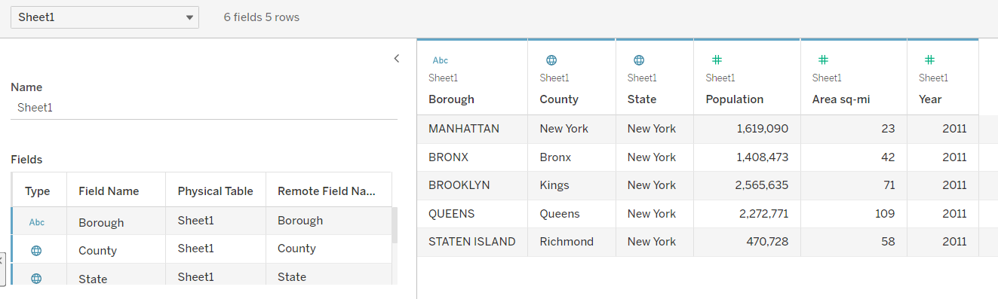

To create a calculated field, first Right click any location in Dimensions or Measures area and select “Create Calculated Field”

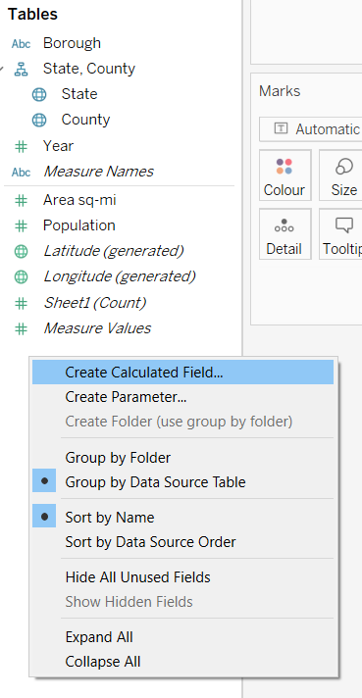

Then input density formula as following. After clicking OK button, a new field of “Population Density” you just created will appears in the Measures area.

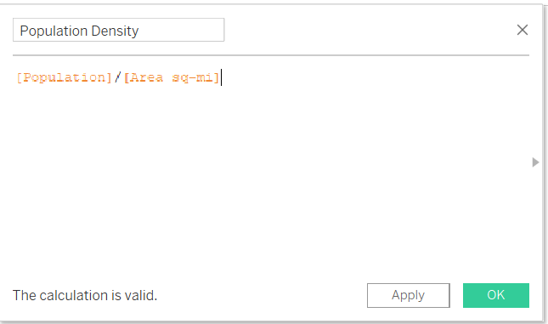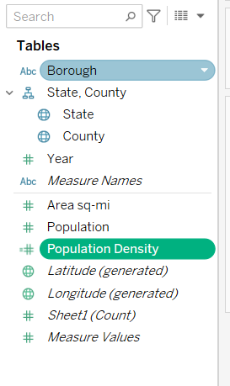

In order to create a filled map to display population density, first select “County”, hold down the “Control key” and then select “Population Density”

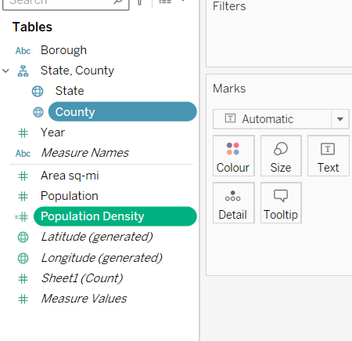

And then select “filled map” in Show Me card

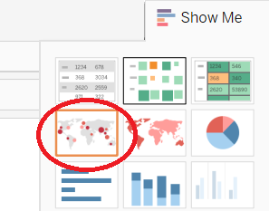

The worksheet will display filled map of population density based of “County” and “Population Density”

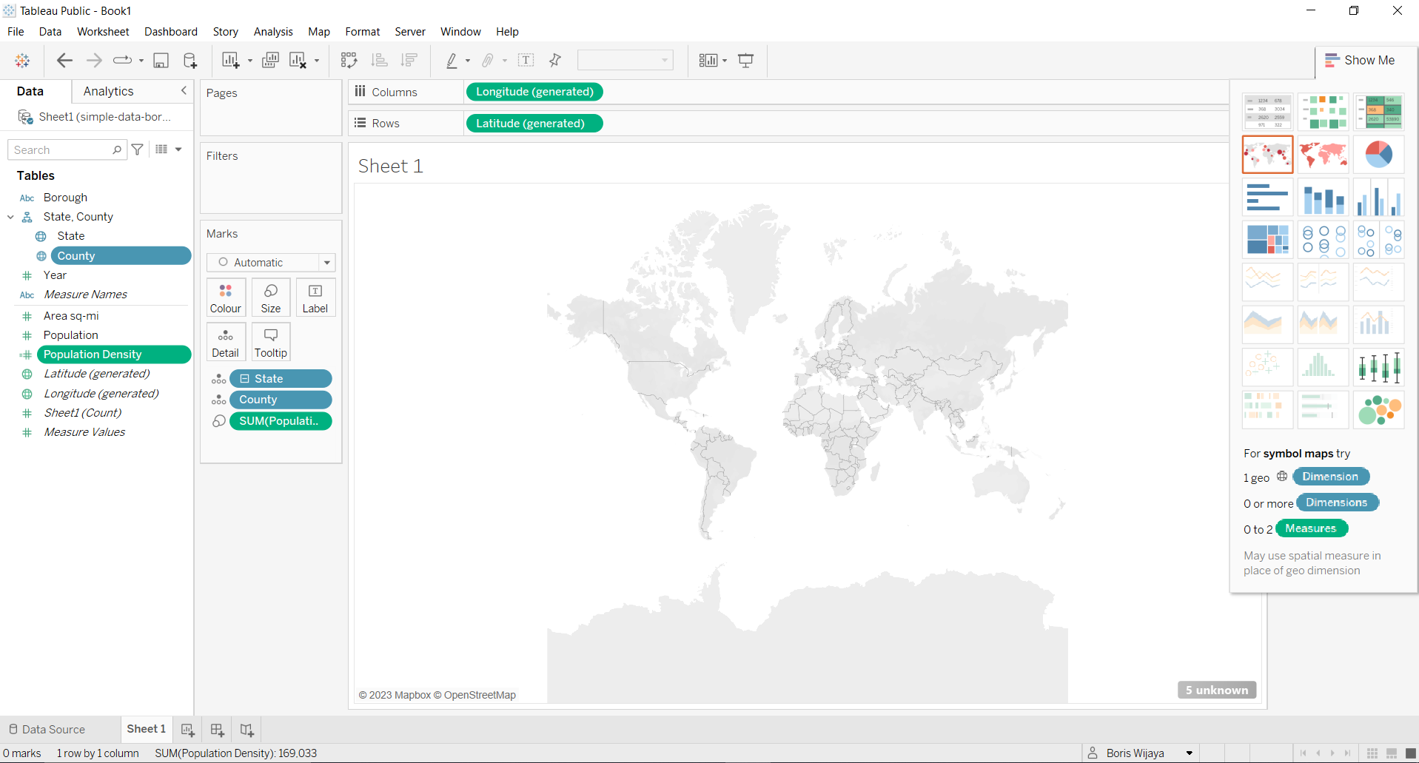

Next we want to Edit location, from the lower-right area of the map, there is a gray text (5 unknown).

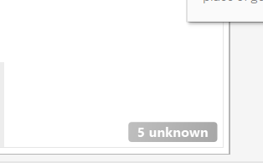

This indicates that five geographic records are unrecognized in dataset. So we need to change location from Australia to United States.

First clicking the gray text to open a menu

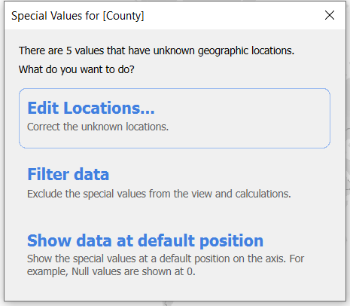

Click Edit Location and change location from”Australia” to “United States”

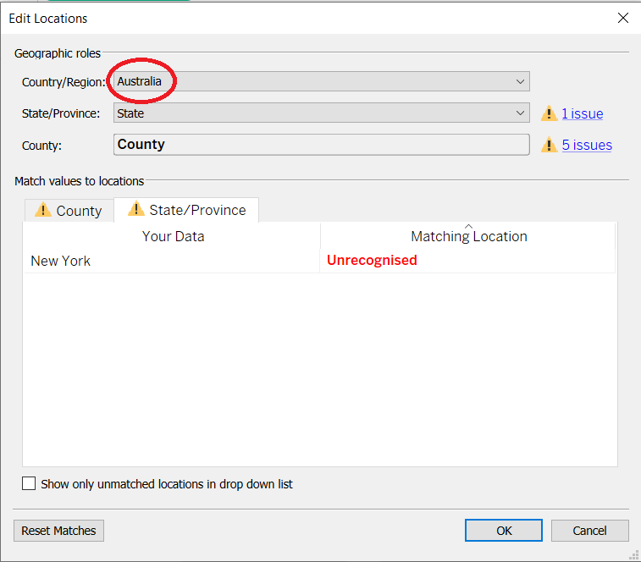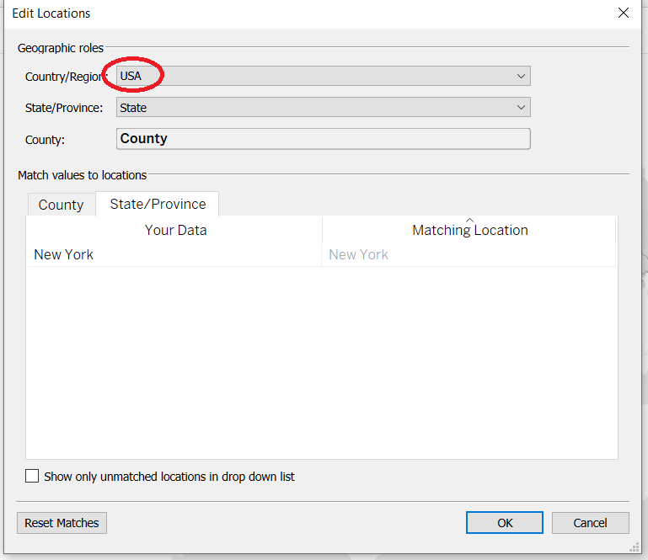

Next we add label to map by drag “County” to “Label” in the Marks card.

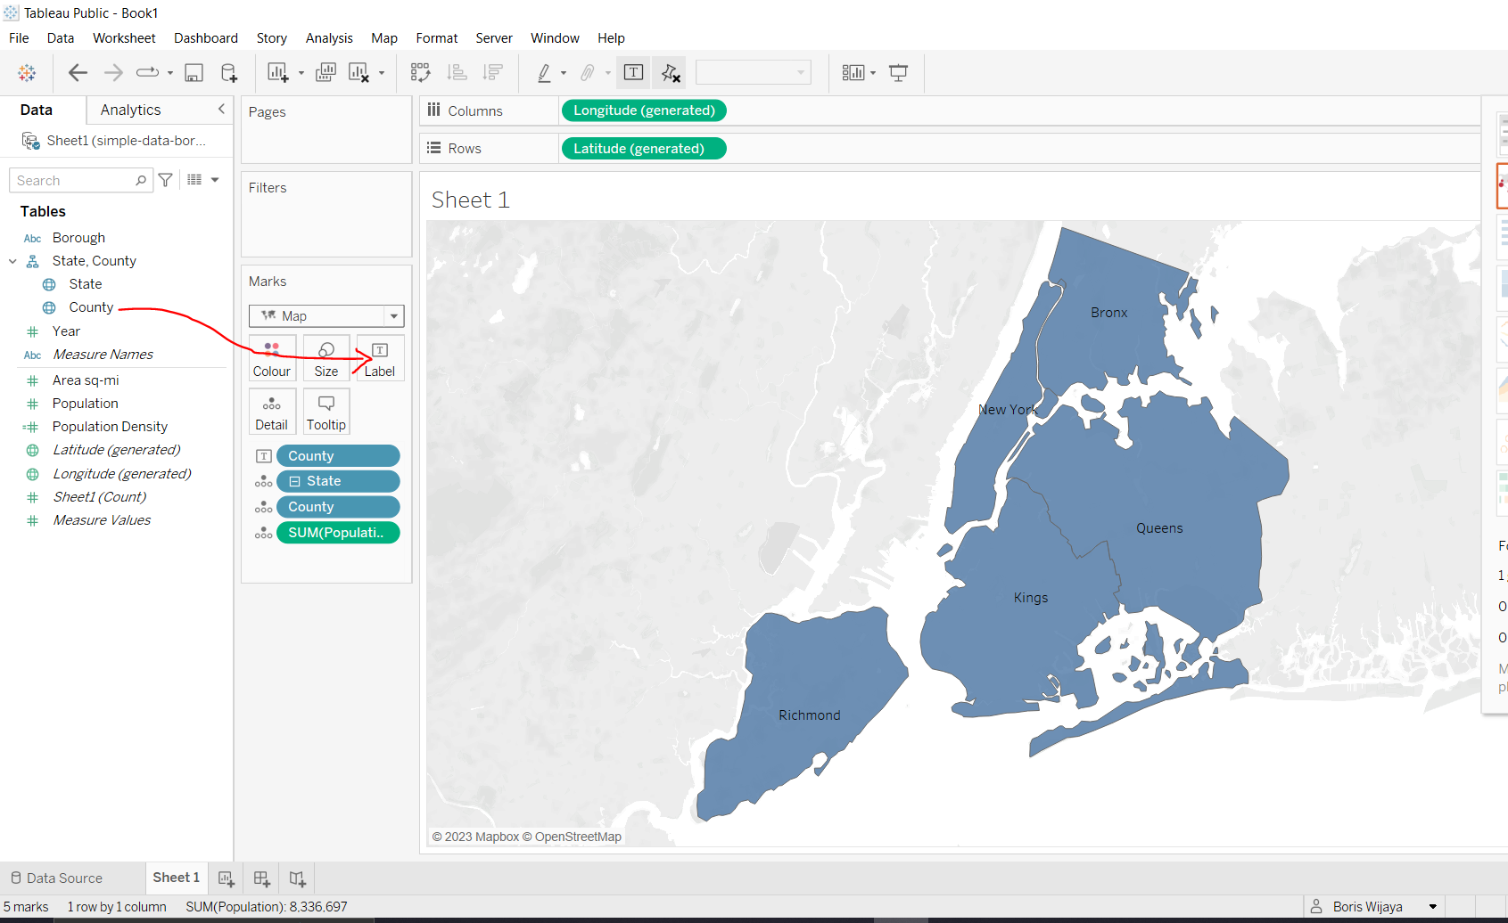

Question of Project-1

Based on the above filled map, which county has the highest population density? Why?

The “Kings” county has the highest population density, because by hovering the area of each label county we able to see the information of that county as shown below.

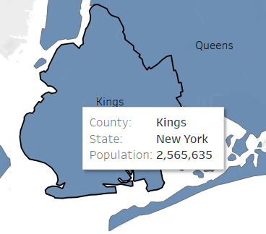

Exercise of Project 2 - Use parameter controls

First we need to download dataset: “club-game-data.xlsx” from Week 4 in Moodle, then Load the data into Tableau

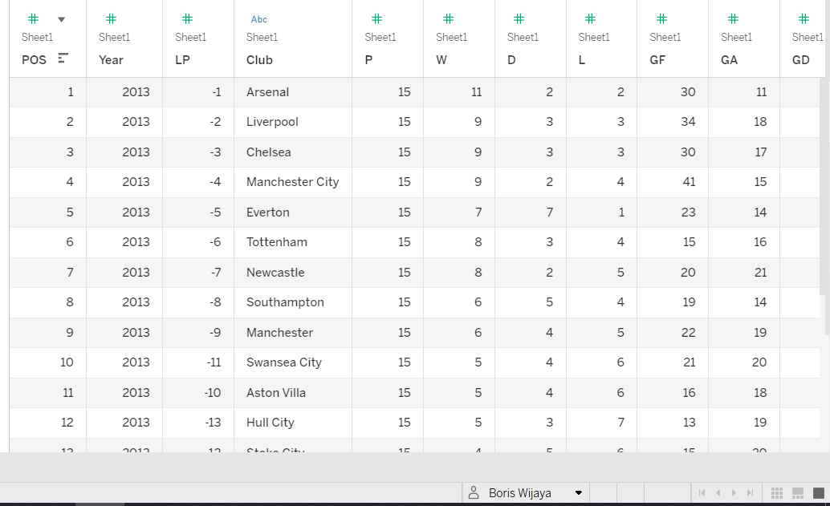

“Right click” any location in Dimensions and Measures area and select Create Parameter.

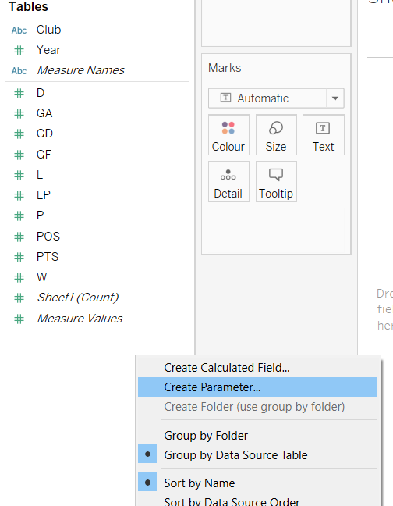

Then type as following below

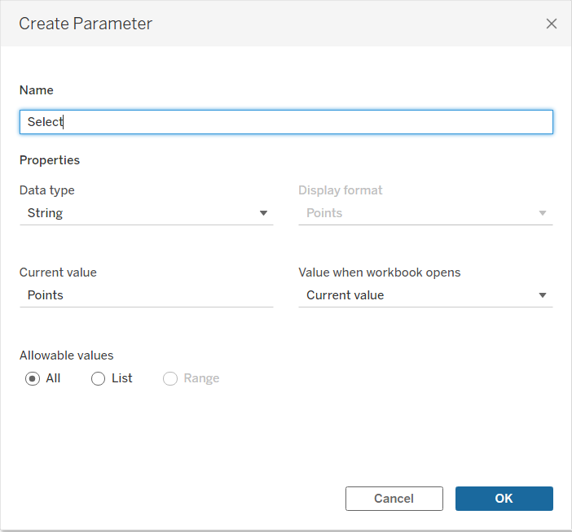

After clicking OK button, you would see that the parameter “Select” you just created will appears at the bottom left.

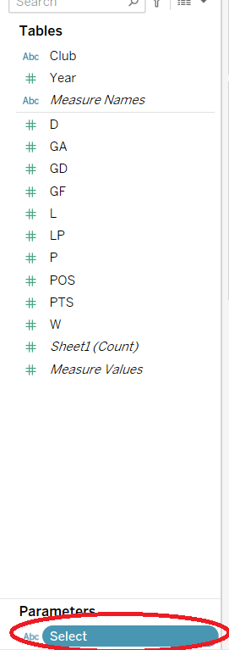

Next, we “Right click” any location near Parameter area, select “Create Calculated Field” and fill out the box. After clicking OK button, you see that “Selected” appears in Measures area.

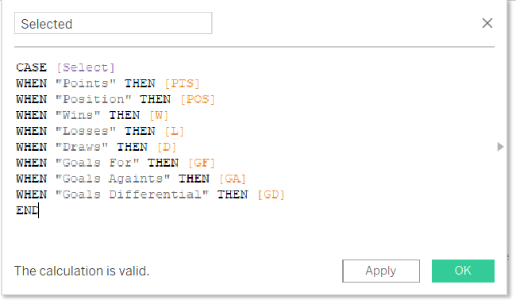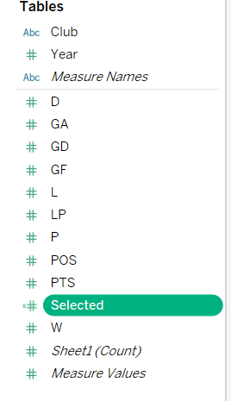

We now use the newly created calculated field to create slopegraph.

Drag “Year” to “Columns shelf”, right click Year in “Columns shelf” to select “Discrete”. This will change Year from continuous data type (green color) to discrete data type (blue color).

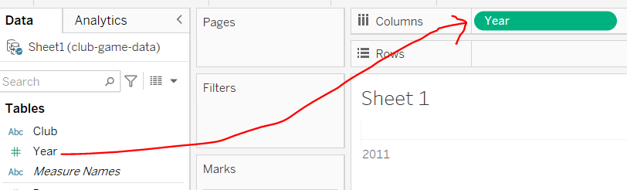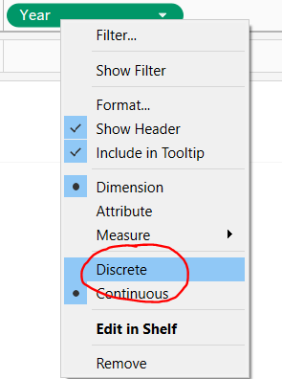

Drag “Selected” you just created to “Rows shelf”, navigate to “Marks card” area and change Marks type from “Automatic” to “Line”.

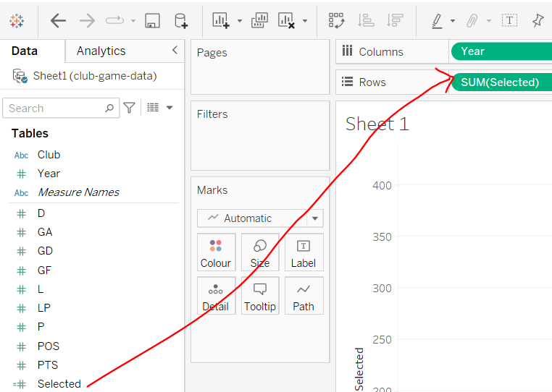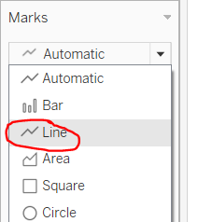

Drag “Club” to Detail in “Marks area” and resize the view.

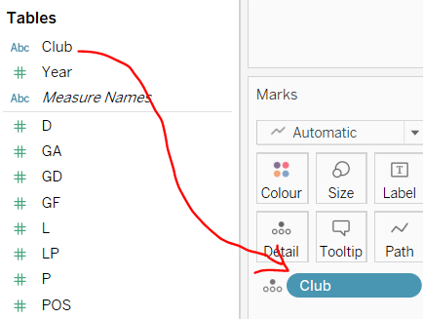

and then drag another “Club” from Dimensions to “Label” in Marks area.

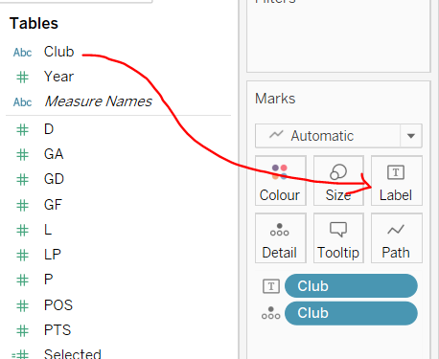

In “Marks area”, click the “Label” and untick “Allow label to overlap other marks” and select “Line ends”

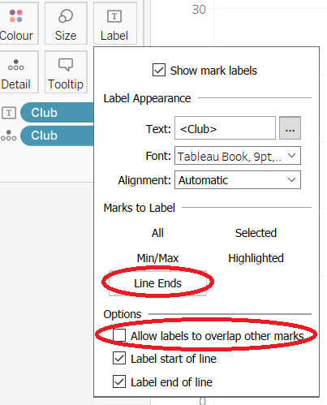

Then we finally finish making the slopegraph

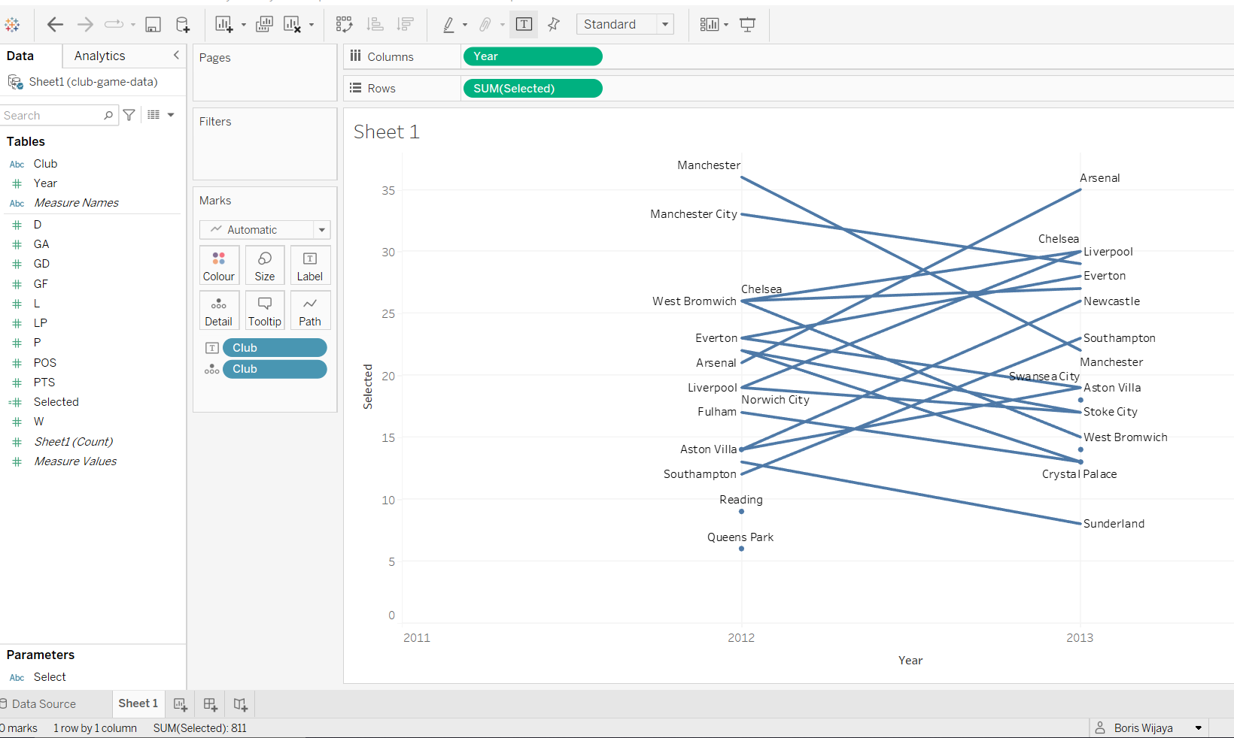

To change line thickness, we can create two calculated field for that, a calculated field “Delta” and a calculated filed “Magnitude”

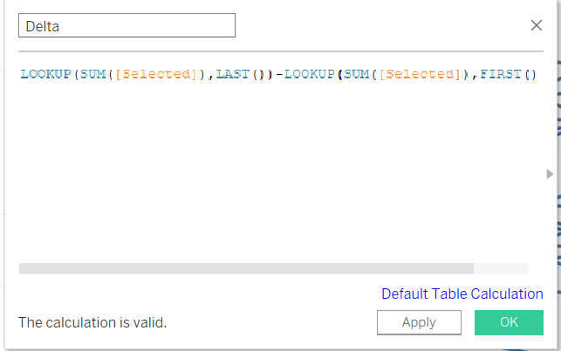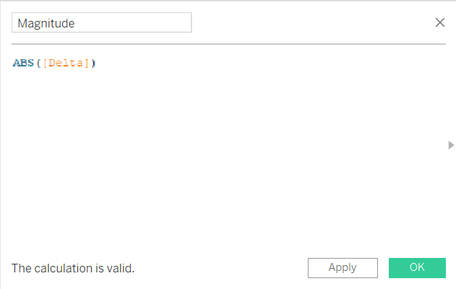

Drag “Magnitude” to Size and drag “Selected” to Label in “Marks area”

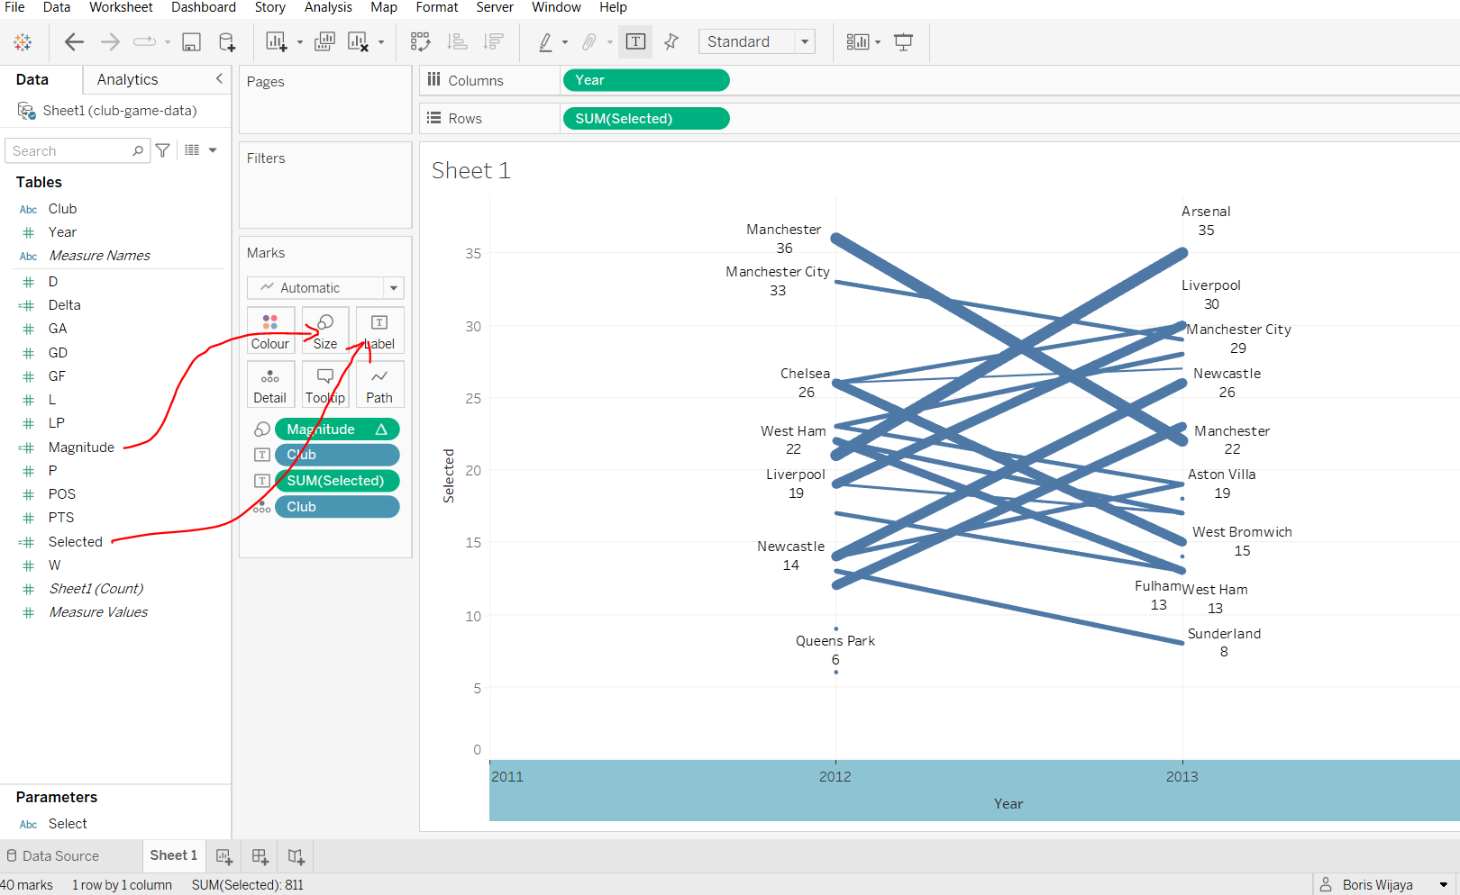

Next we create dashboard by click “Dashboard” on the top tool bar, drag “Sheet 1” from the left pane to the centre and change dashboard title

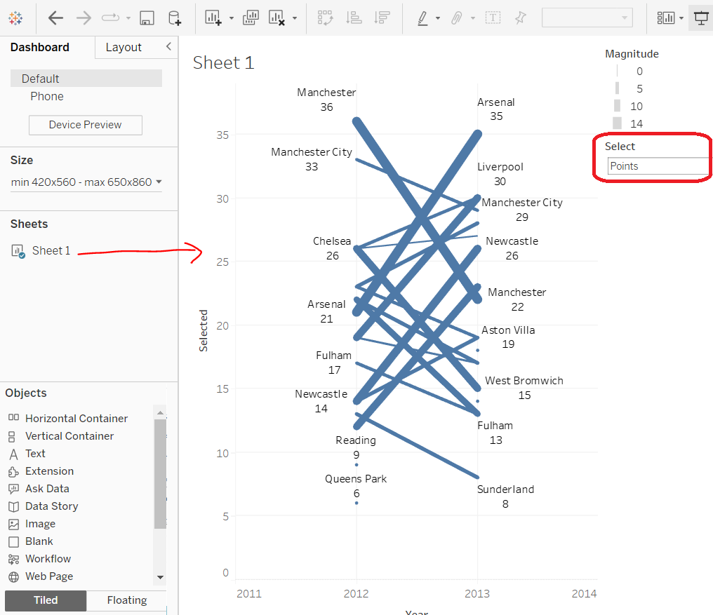

Exercise of Project 3 - Explore different color coding schemes

Download data set: “product–sales–customer.xlsx” from Week 4 in Moodle, then Load the data into Tableau

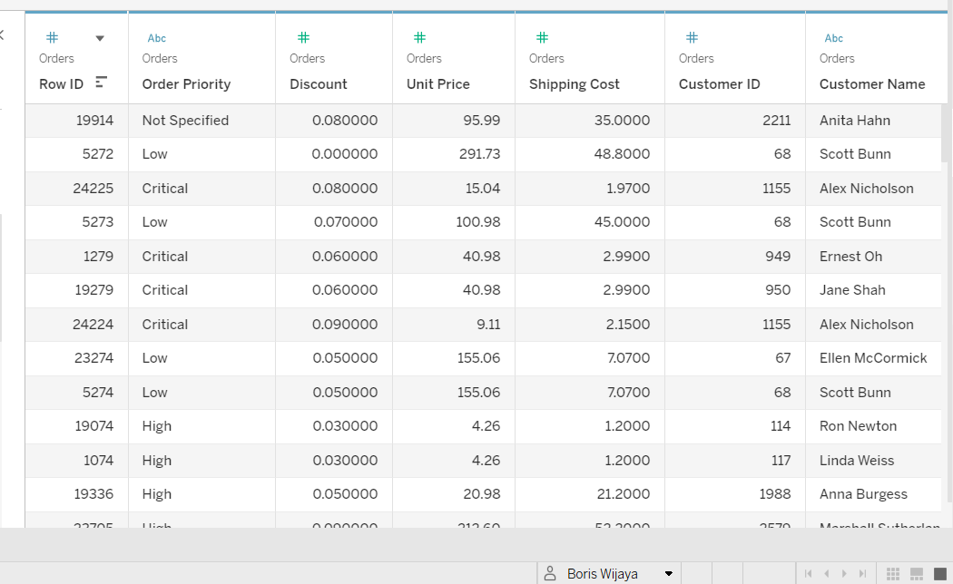

Drag “Product Sub-Category” to Rows shelf, then drag “Sales” to Columns shelf, then sort the bars in descending order.

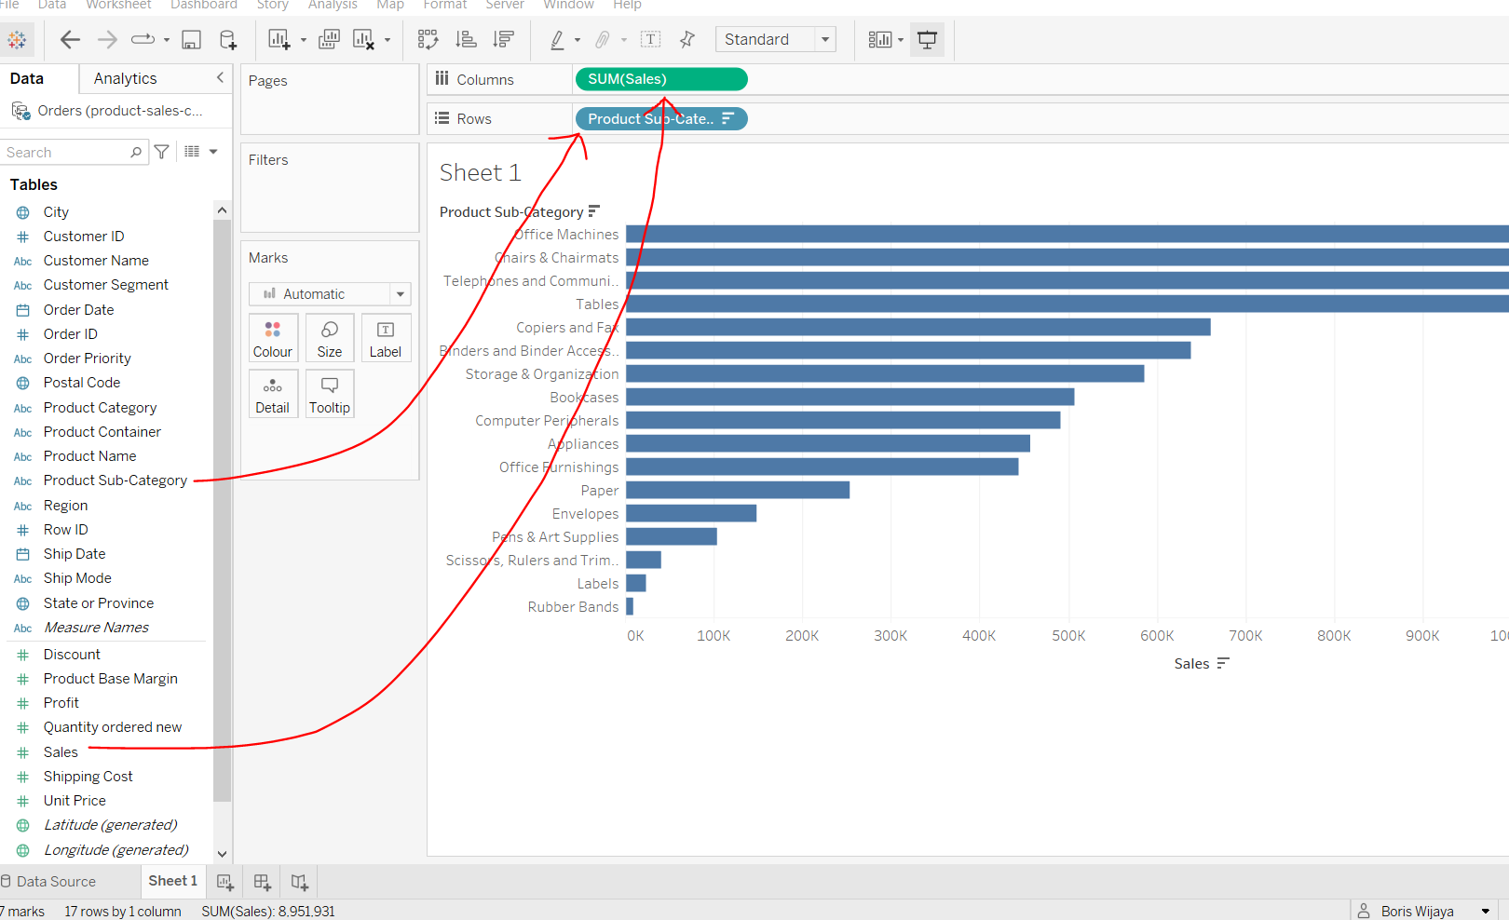

Drag “Product Sub-Category” to the “Color” shelf and drag “Sales” to “Label” shelf.

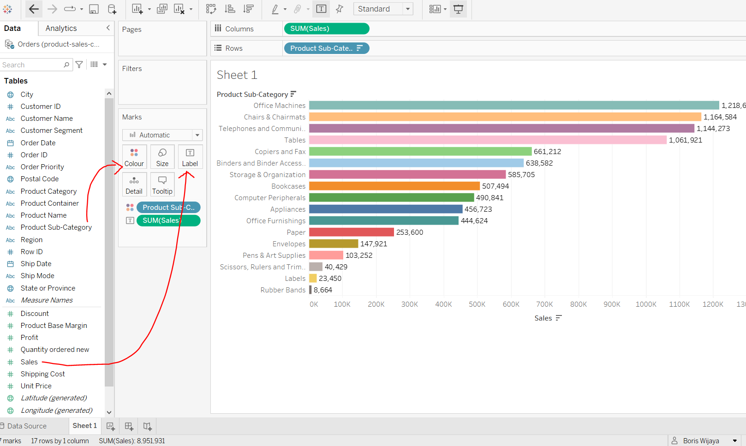

We can customized colors for individual marks by clicking “Color” button, and click “Edit Colors” to select required color

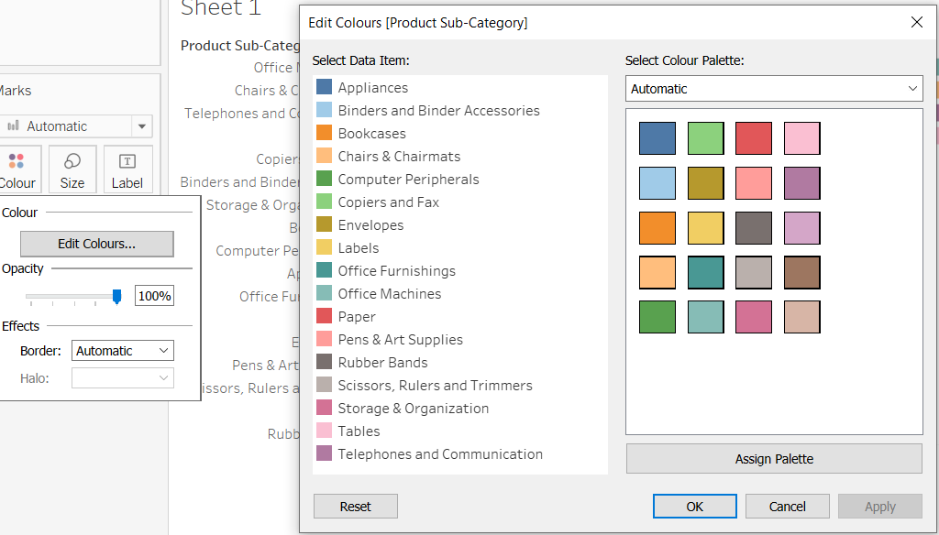

To compare the bar chart with the pie chart, first click on the pie chart in the “Show Me” panel, and drag the “Sales” to the “Label” shelf.

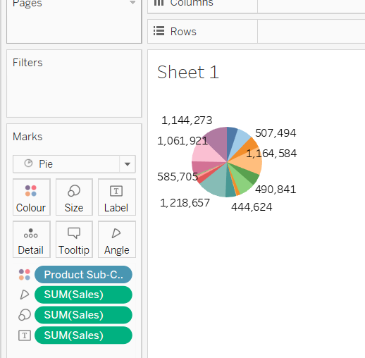

Disccusion of Pie chart from before

1. Are colors used effectively?

Yes, because the colour help to draw readers in to the graph and also help them to better understanding about the graph details

1. Does this visualization encourage any misperceptions?

Yes, there is posibility of misperceptions from the chart, because the chart did not label each colour with specific details, so it confusing for other to read it.

1. How could this visualization be improved? Offer specific suggestions.

The visualization of chart above can be improve by having less section so it’s easy to read, and resize the grapgh visual so readers know which label correspondence to what colour.

Exercise of Project 4 - Visualizing spatial data

The purpose of this project is to understanding map as an effective approach for visualizing spatial data

First download dataset: “borough-population-area.xlsx” from Week 4 in Moodle and load it into Tableau.

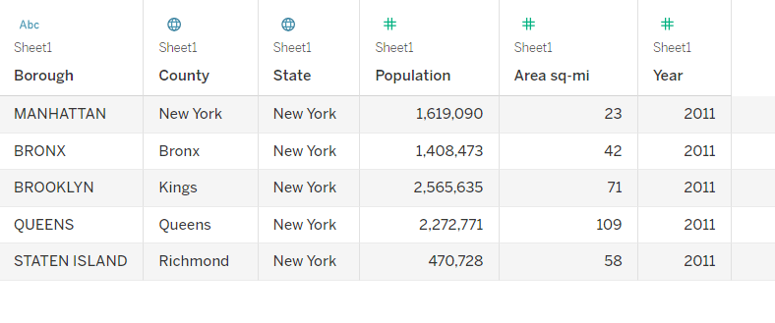

“Double-click” on the geographic data field “State” and double-click on geographic data field “County” to show background map.

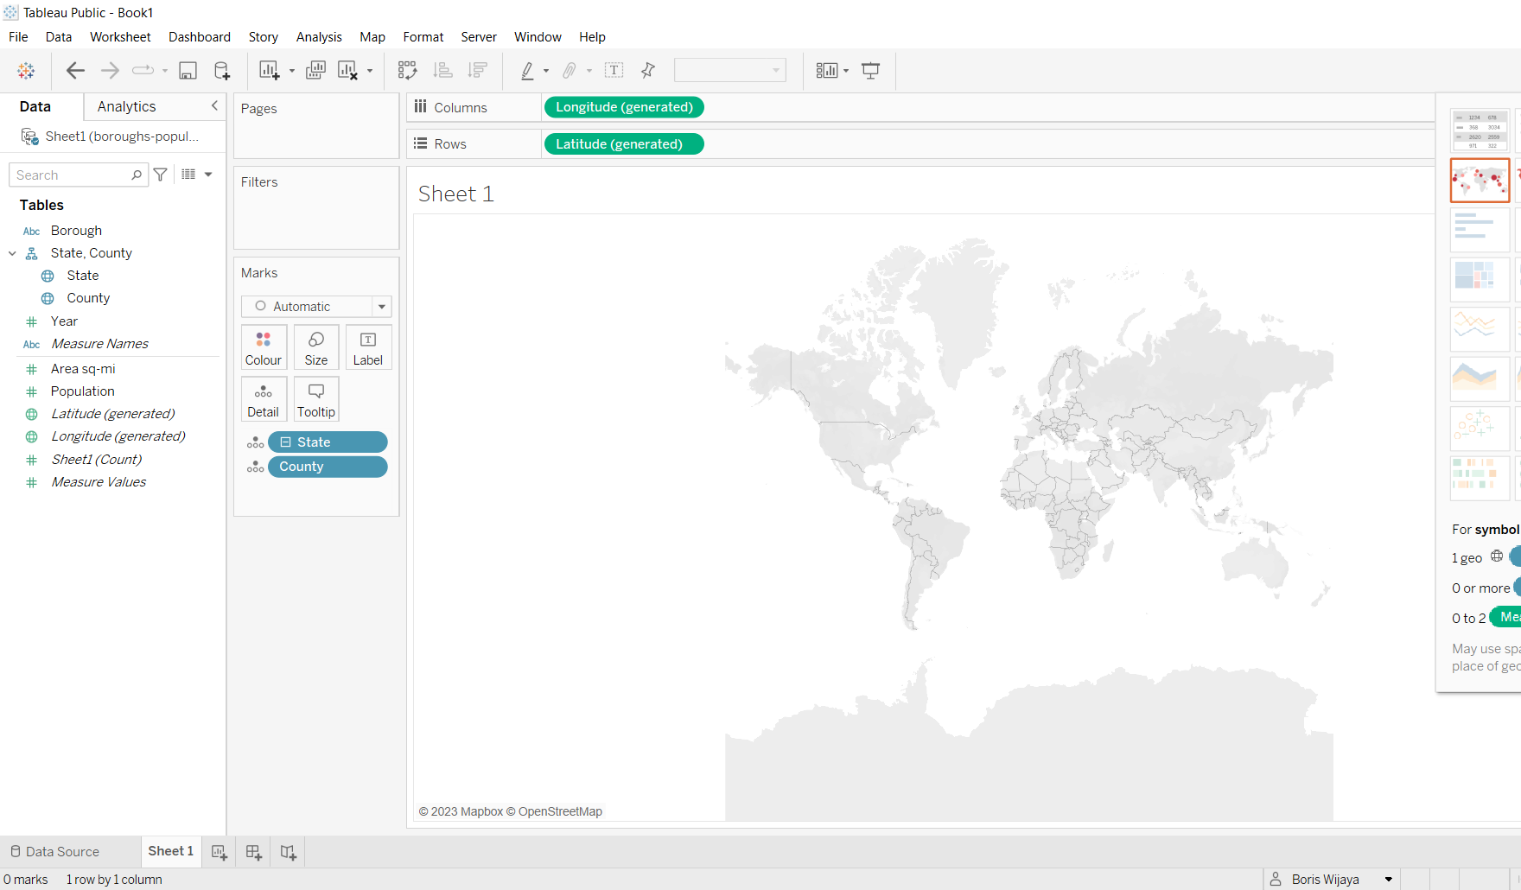

There is gray text on the left bottom label “5 unknown”, click it to edit location data

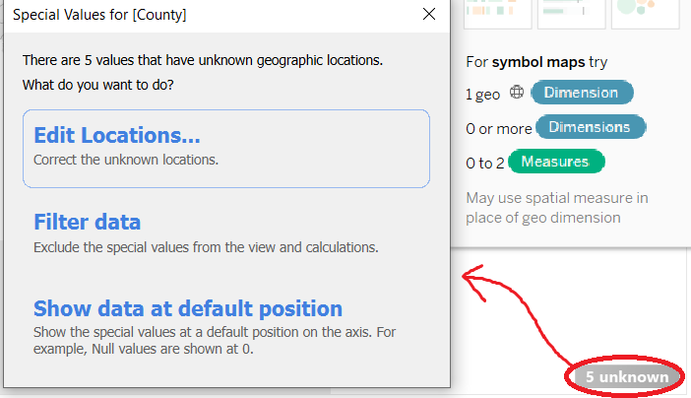

Change County/region from Australia to United States.

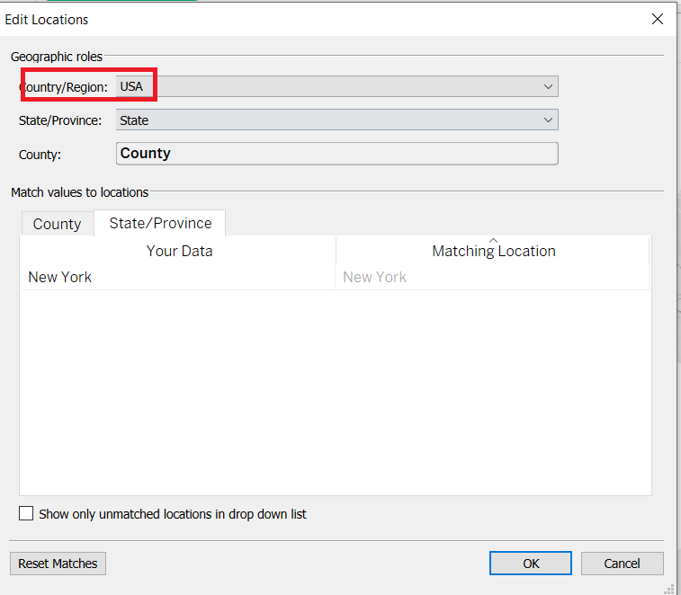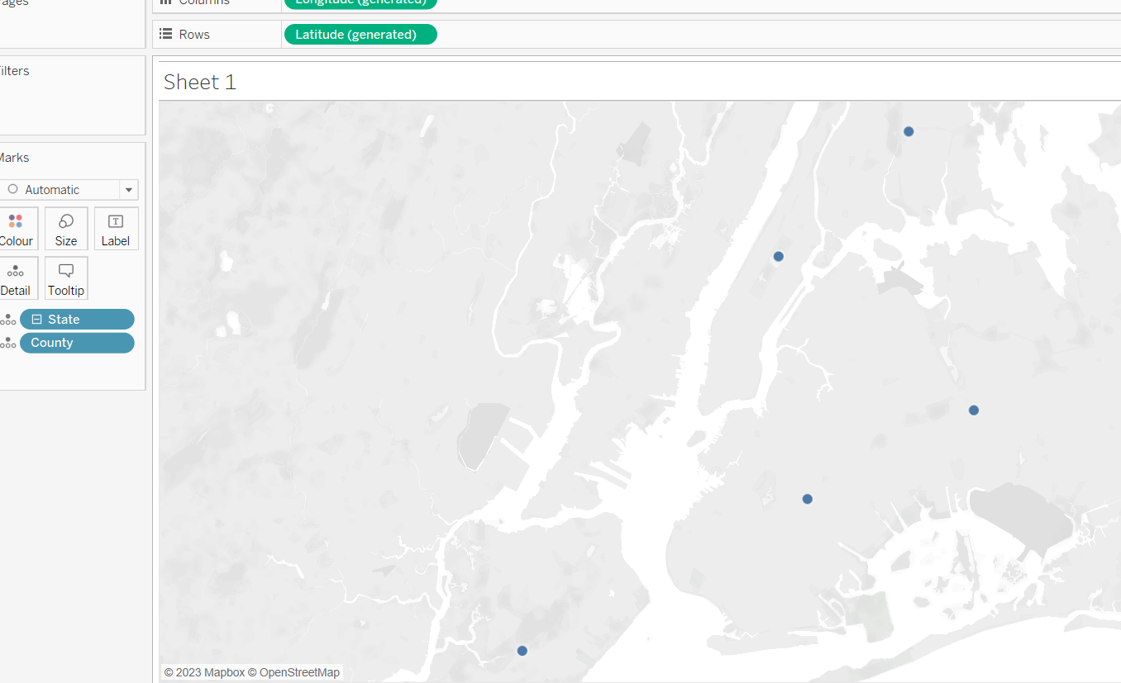

Add population information to the map by dragging “Population” from the “Measures” shelf to ”Size” shelf

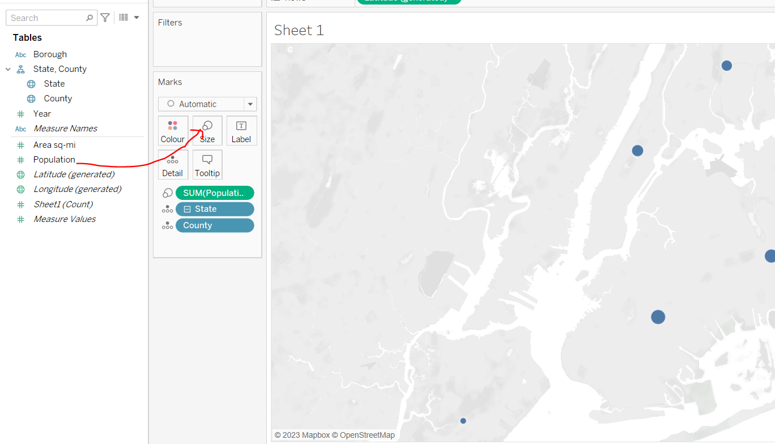

Create a new calculated field to show population density. Right-click anywhere in the 'Dimensions' or 'Measures' area and select 'Create Calculated field'.

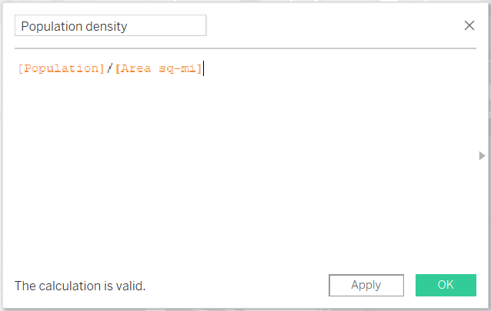

Drag the 'Population Density' field to 'Color' shelf and change color to green

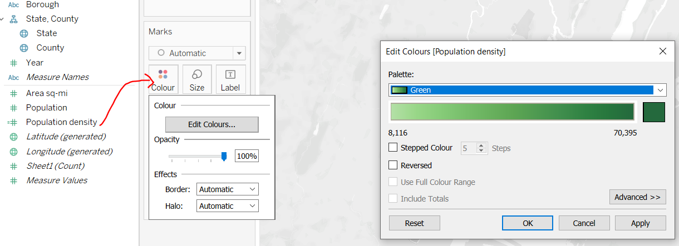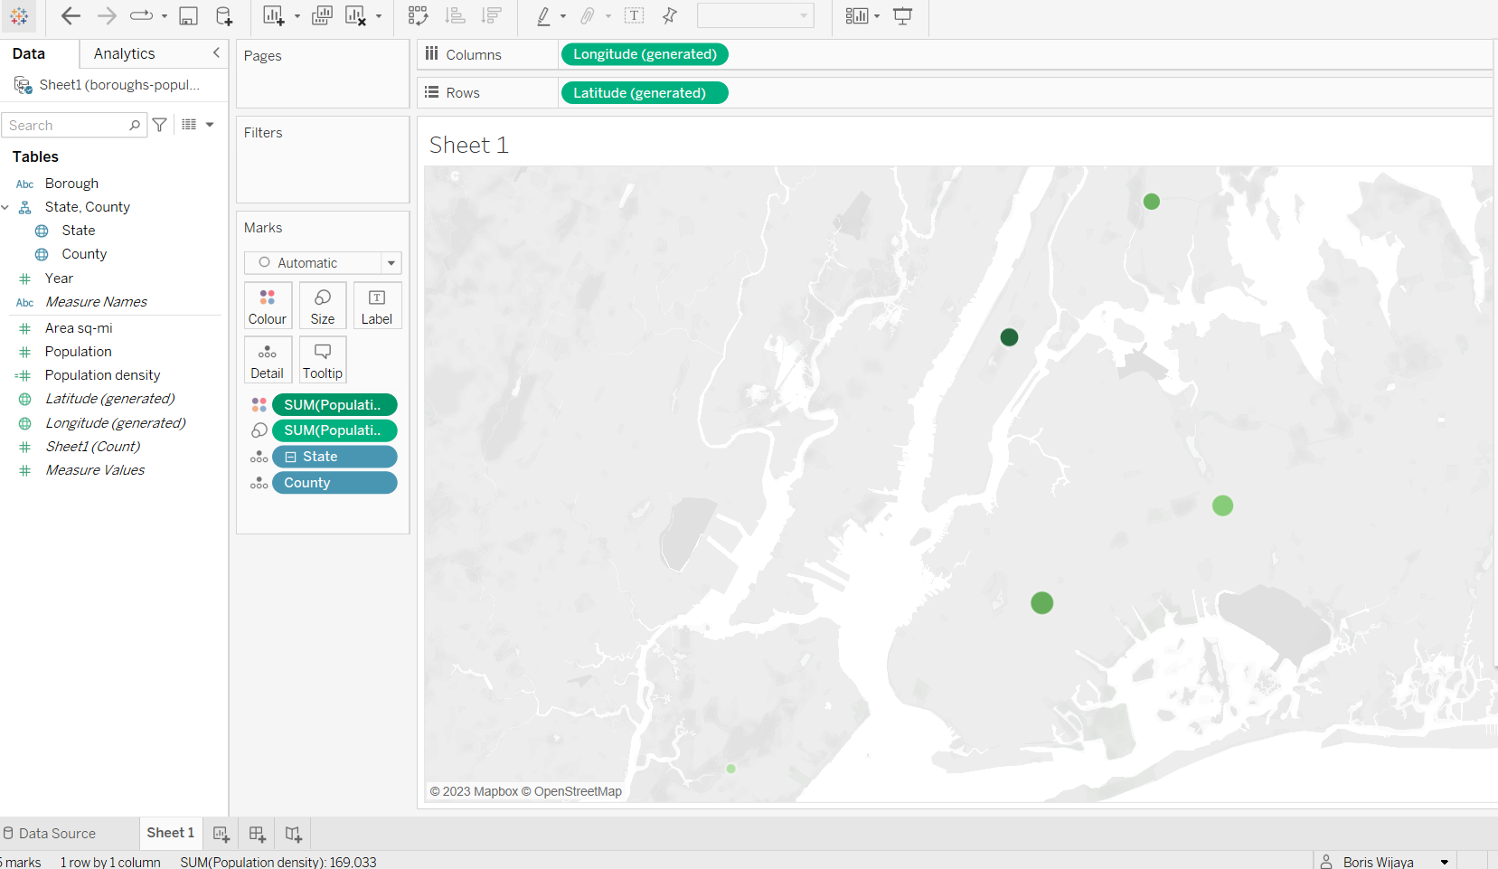

Amswering Questions of Lab-4 Exercise

1. List and describe the three major categories of business reports.

**Analytical Reports**

Analytical reports are critical for any company and help in times of crucial decisions. It helps the management to get the relevant data with detail descriptions. For instance, the report would comprise the necessary activities taken by the executive team, the numbers from sales revenue, and the net profit or loss of the company’s first year. It helps the businesses to analyze the operations that have occurred during the first year thus helping the company to make future decisions.

**Informational Reports**

Informational reports are documents that include all company information inside of it. It gives information on the number of employees, the departments they work in, the number of employees, and what is the role of each employee in the organization. It can be showcased in different ways like a graph, pie chart, or a table showing the employing details and so on.

**Research Reports**

Research reports are the ones created when a company is planning to venture into new areas, like launching a new product in the market or planning an expansion of its office in a new geographical area. A research report includes information about the relevant details and stats on a specific topic that the company uses for its future development.

1. Carefully analyze Charles Joseph Minard’s graphical portrayal of Napoleon’s march. Identify and comment on all of the information dimensions captured in this ancient diagram

Minard’s graphic is notable for its representation in two dimensions of six types of data: the number of Napoleon's troops; distance; temperature; latitude and longitude; direction of travel; and location relative to specific dates. He shows these various details without distracting text or labels as well.

For example, he displays the Forces visual comparisons (the upper lighter band showing the large army going to Moscow vs. the narrow dark band showing the small army returning). And display points where Napoleon’s troops divide into subgroups by breaking the main bar into branches.

1. Why would you use a geographic map? What other types of charts can be combined with a geographic map?

Geographic maps are used to display the world in a different way by mapping the position and quantity of things, mapping the density of people and objects and they can reveal important patterns of events or occurrences in the world.

There are other charts that can be combine with geographic map. For example, bar charts and line graphs can be combined together with a geographic map to create climate graphs of the world. Another example, is a map chart that can be used to label metrics against geographical locations such as country, county, state/province, city, zip code, latitude and longitude